**Isidora Pacific Thick Splitface Effect Tiles:** 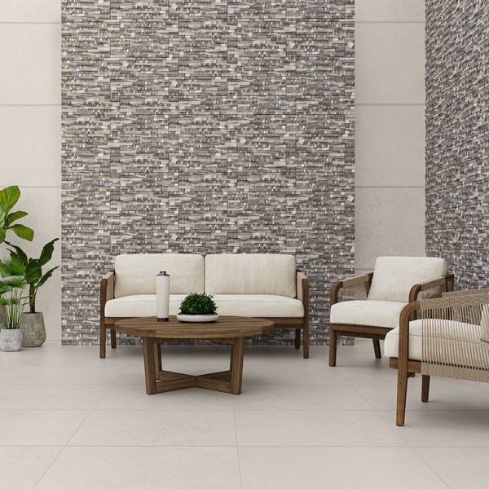

## **Product Description**

Add depth and character to any space with our Isidora Pacific Thick Splitface Effect Tiles. Designed to emulate linear strips of stone, these tiles feature a mottled mix of grey and sea green with a rippled, wave-like effect and a light shimmer across the surface. A low maintenance alternative to natural split face tiles, these stunning staggered porcelain tiles have a rugged, multi-levelled surface, providing a sleek, contemporary look in your home.

**What’s special about these tiles?**

> Rustic three-dimensional surface

> Gentle sparkle effect

> Sleek contemporary aesthetic

> Durable porcelain

> Striking characterful look

## **Product Info**

* Product ID: 801526
* Tiles Per SQM: 11.31221719457
* Sale by: Per SQM
* Size: 170x520x14mm
* Weight: 2.04 KG
* Material Type: Porcelain
* Finish: Matt
* Colour: Grey
* Suitability: Walls
* Area Of Usage: Internal, External
* Grade: No
* Rectified Edge: No
* Underfloor Heating: No
* Thickness (mm): 14